49 slides

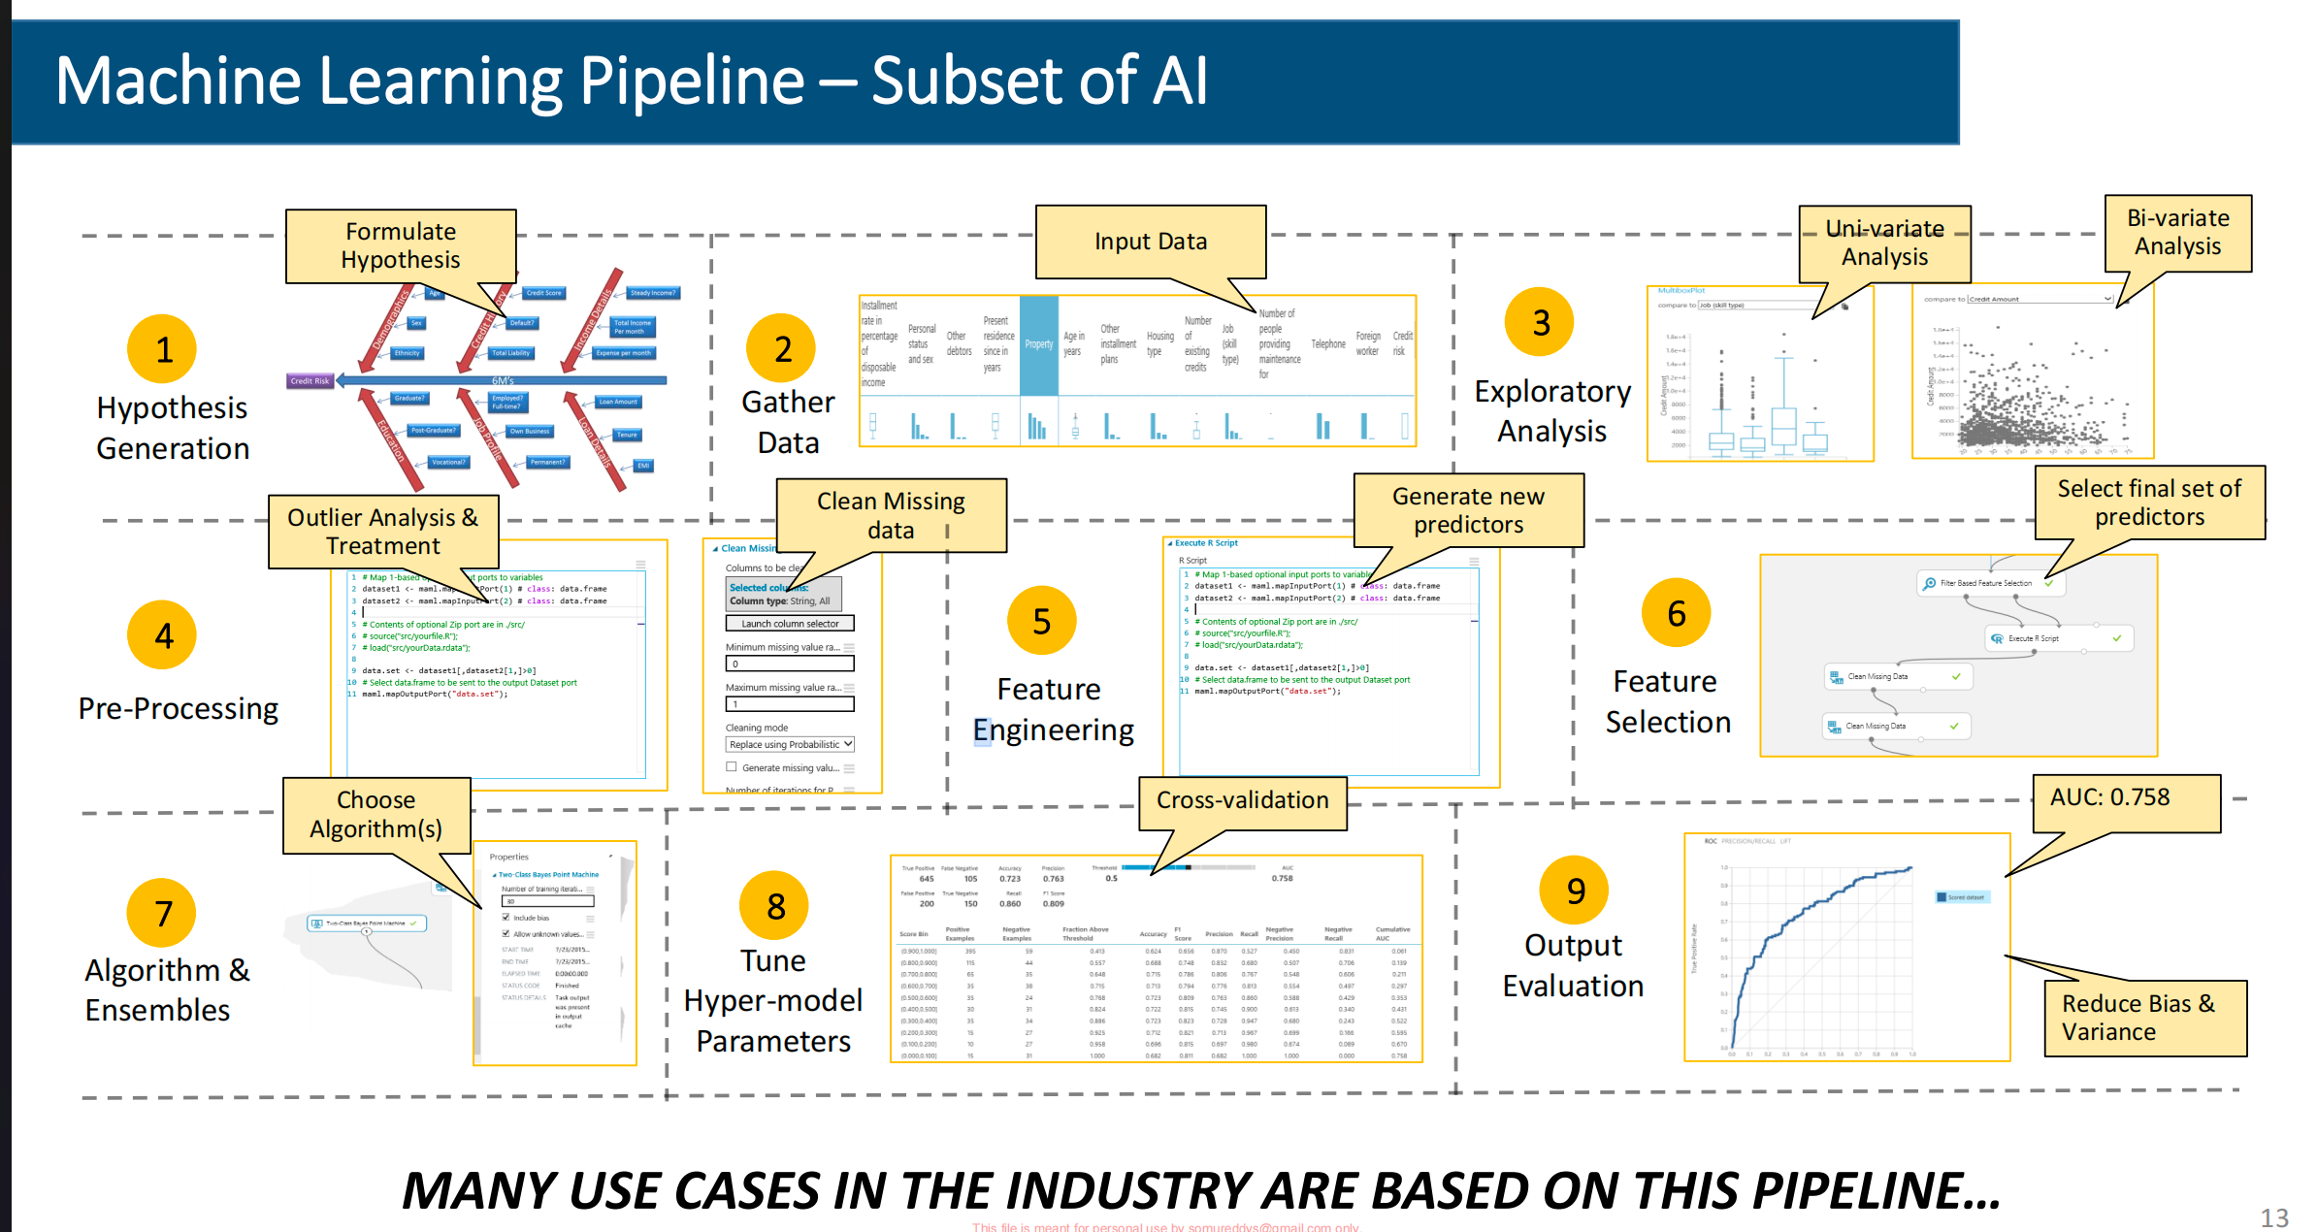

This image shows a typical Machine Learning (ML) pipeline, which is presented as a subset of broader Artificial Intelligence (AI) workflows. It outlines the end-to-end process used to build, train, evaluate, and improve machine learning models.
Here’s what each stage means:
1. Hypothesis Generation
The process starts with defining the problem and forming assumptions about what might influence the outcome.
Examples:

“Customer income may affect loan approval.”

“User activity may predict churn.”

Goal:

Identify potential factors (features/predictors)

Understand the business problem

2. Gather Data
Data relevant to the problem is collected from databases, APIs, logs, surveys, sensors, etc.
Examples of data:

Customer age

Transaction history

Website clicks

Medical records

Goal:

Build a dataset containing input variables and target labels

3. Exploratory Analysis (EDA)
This step analyzes the dataset to understand patterns, distributions, relationships, and anomalies.
Two major analyses shown:
Uni-variate Analysis
Looks at one variable at a time.
Examples:

Distribution of ages

Histogram of salaries

Box plots for outlier detection

Bi-variate Analysis
Examines relationships between two variables.
Examples:

Correlation between income and spending

Scatter plots of features vs target

Goal:

Understand the data before modeling

4. Pre-Processing
Raw data is cleaned and transformed into usable form.
Tasks shown:

Outlier analysis and treatment

Cleaning missing data

Typical preprocessing tasks:

Handling null values

Removing duplicates

Scaling/normalizing data

Encoding categorical variables

Goal:

Improve data quality for learning algorithms

5. Feature Engineering
New features (predictors) are created from existing data.
Examples:

Age → Age groups

Date → Day of week / season

Transaction history → Average spending

Goal:

Create more informative variables that improve model performance

This is often one of the most important steps in ML.
6. Feature Selection
Not all variables are useful. This stage selects the best subset of features.
Why?

Reduces noise

Prevents overfitting

Speeds up training

Improves interpretability

Methods:

Correlation filtering

Recursive feature elimination

Statistical tests

Tree-based importance ranking

Goal:

Keep only meaningful predictors

7. Algorithm & Ensembles
Now the ML model is chosen and trained.
Examples of algorithms:

Linear Regression

Decision Trees

Random Forest

XGBoost

Neural Networks

SVM

“Ensembles” combine multiple models to improve performance.
Examples:

Bagging

Boosting

Stacking

Goal:

Learn patterns from data

8. Tune Hyper-Parameters
Hyperparameters are settings configured before training.
Examples:

Tree depth

Learning rate

Number of estimators

Regularization strength

The image mentions:
Cross-validation
A method where data is split multiple times to test model robustness.
Goal:

Find the best model configuration

Reduce overfitting

9. Output Evaluation
The trained model is evaluated using metrics.
The image shows:
AUC = 0.758
AUC (Area Under ROC Curve) measures classification quality.

1.0 = perfect

0.5 = random guessing

0.758 = reasonably good model

Also mentioned:
Reduce Bias & Variance
This refers to balancing:

Bias → underfitting

Variance → overfitting

Goal:

Build a model that generalizes well to new data

Overall Flow
The pipeline can be summarized as:
Problem Understanding
↓
Data Collection
↓
Data Exploration
↓
Data Cleaning
↓
Feature Engineering
↓
Feature Selection
↓
Model Training
↓
Hyperparameter Tuning
↓
Evaluation & Improvement
Key Insight From the Image
The diagram emphasizes that successful ML systems are not just about algorithms. A large portion of effort goes into:

understanding data,

cleaning it,

engineering features,

and validating models properly.

In real-world industry projects, preprocessing and feature engineering often consume more time than model training itself.

